 | Year 12 ATAR Physics 4 2018  Evaluation and Analysis 3.0%  NAME: ………………………………………………….  Data: See Data Sheet  Approx. marks shown.  (48 marks)

When calculating numerical answers, show your working or reasoning clearly. Give final answers to three significant figures and include appropriate units where applicable.
When estimating numerical answers, show your working or reasoning clearly. Give final answers to a maximum of two significant figures and include appropriate units where applicable.

Part B Quiz
- (a) A black body in the laboratory may consist of a hollow porcelain sphere with a small hole in it.  The inside is blackened with soot. A beam of light is directed at the sphere so that it strikes the hole at an angle. The beam of a variety of wavelengths bounces around the inner walls and is entirely absorbed by the sphere.  Explain why the hole is considered to be a black body. [1] | 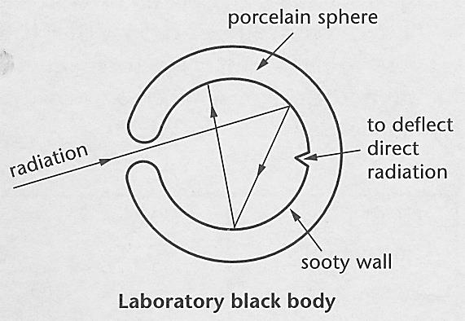

..........................................................................................................................................

..........................................................................................................................................

..........................................................................................................................................

(b) In 1896, Wien found that the product of the temperature of a black body and the wavelength of the emitted radiation, in metres m, produced a constant: 2.90 x 10^{–3}. This relationship is known as Wien's displacement law.
(i) Write this formula as a mathematical relationship. [1]

….......................................................................................................................................

(ii) Calculate the peak wavelength, in metres m and nanometers nm, which corresponds to 1400 K using Wien's displacement law. [2]

….......................................................................................................................................

….......................................................................................................................................

….......................................................................................................................................

….......................................................................................................................................

(c) In 1900, another scientist described the process more accurately by including the constant h with a mean value of 6.626 x 10^{–34} Js. It was from this radiation equation that this scientist developed the basis for what we know as quantum theory.
Suggest the name of this scientist. [1]

….......................................................................................................................................

- As a blackbody heats up, it emits all of the energy it has received back into space. Although all wavelengths are emitted, the dominant wavelength directly corresponds to the effective surface temperature of the black body according to Wien's displacement law.
The table below was the result of an experiment in black body radiation. The coordinate pairs give a curve corresponding to an effective surface temperature (T_{eff}) of 1400 K.

E | 1.5 | 4.5 | 8.0 | 5.5 | 3.0 | 1.0
λ | 1000 | 1500 | 2000 | 3000 | 4000 | 5000

where E = the emissive power in Wm^{–2} nm^{–1} x 10^{–9}, and
λ = wavelength in nanometres.

- On the grid on pg 3 draw a graph of the black body radiation curve for 1400 K, plotting emissive power on the y axis and wavelength on the x-axis. [3]
- Use the answer to question 1 (b) (ii) to estimate the turning point of the curve. [1]

- (a) Use Wien's displacement law to establish the peak wavelengths, in nanometers nm, to 2 significant figures, when:
 | E | T_{eff} | λ
(i) | 18 | 1600
(ii) | 4 | 1200
(iii) | 2 | 1000

where E = the emissive power in Wm^{–2} nm^{–1} x 10^{–9}, and
T_{eff} = is in Kelvin. [3]

- Plot these points on the same graph as in question 2 and join them up with a curved line. This represents the peak radiation for a given temperature. [3]

- Earth, however, is not a perfect black body but a grey body which absorbs and emits about 90% of the radiation it receives from the sun. Earth is therefore regarded as having an emissivity (ε) of 0.90.
Given that the mean surface temperature (T_{eff}) of Earth is 290 K estimate the total outgoing radiation using P = A ε E where A is the area of the surface, 4 π r² and E is the energy derived from Stefan's Law, E = σ T⁴. Stefan's constant (σ) has the value
5.75 x 10^{–8} W m^{–2} K^{–4}. [3]

..........................................................................................................................................

..........................................................................................................................................

..........................................................................................................................................

..........................................................................................................................................

18

16

14

12

10

8

6

4

2

0


- Use the Data Sheet to complete the table below relating the wavelength ranges, in m, associated with ultraviolet (uv), visible, infrared, and microwave spectra. [4]

EM radiation spectrum | Min wavelength  (m) | Max wavelength  (m)
Ultraviolet
Visible
Infrared
Microwave

- What wavelength spectrum is associated with heat radiation? Give an example of a device that relies upon detecting these wavelengths. [2]

..........................................................................................................................................

..........................................................................................................................................

..........................................................................................................................................

- Convert a normal human body temperature of 37°C to Kelvin. Only whole numbers are required. [2]

..........................................................................................................................................

      - Use the blackbody spectrums on the following pages to complete the table below. Note that the peak wavelength is the x-axis value corresponding to the maximum of the blackbody intensity curve. [8]
Object | Temperature | Peak wavelength  (μm) | The primary peak spectrum region
Sun
Light bulb
Oven
Yourself
Earth

Black body Spectra

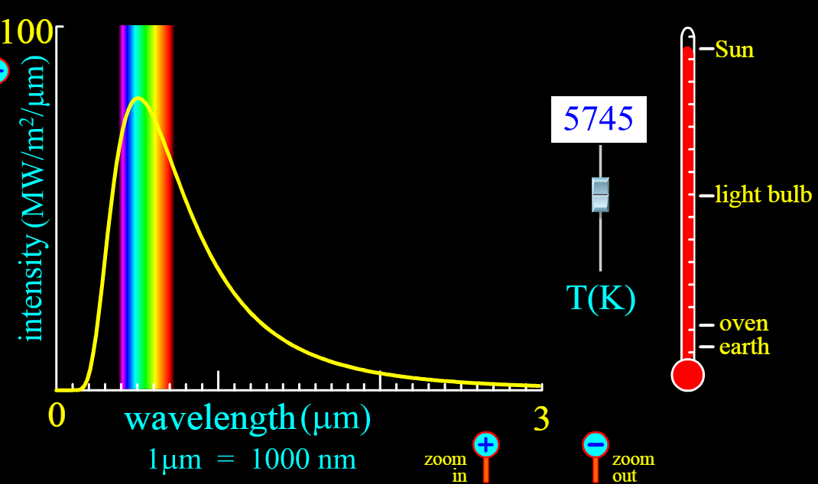

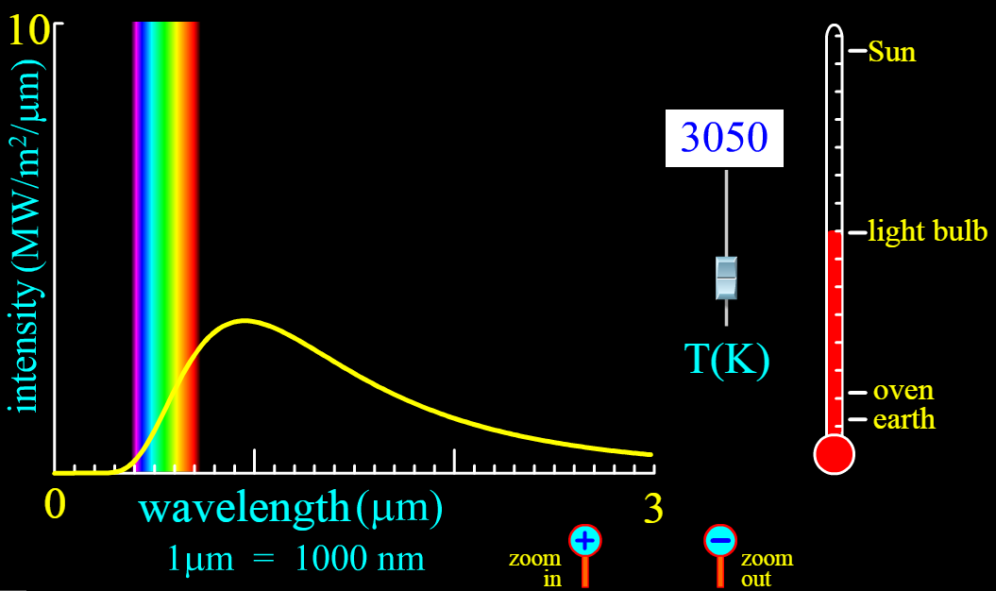

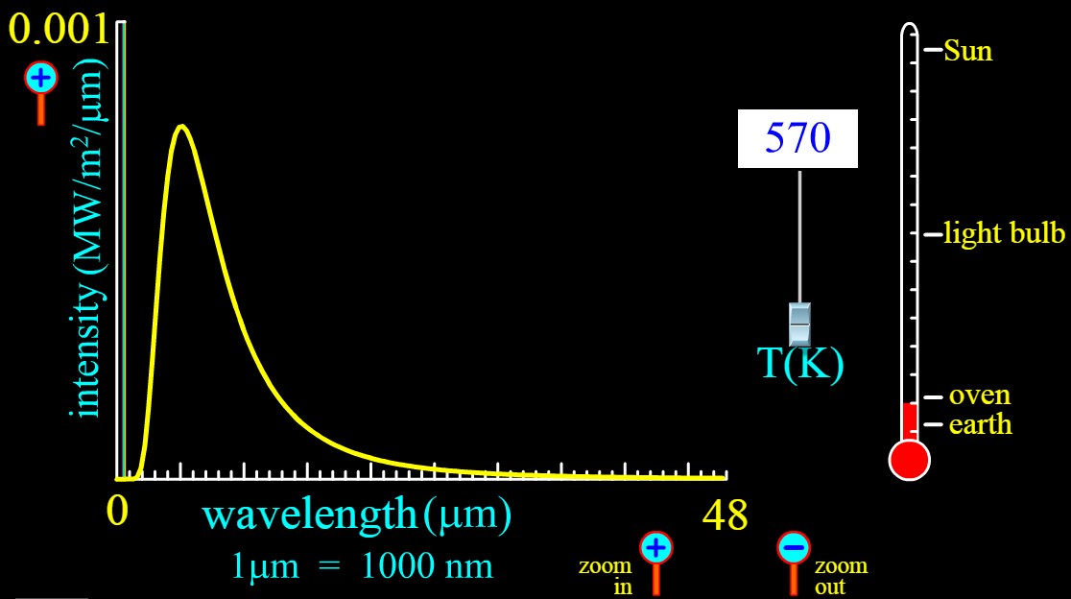

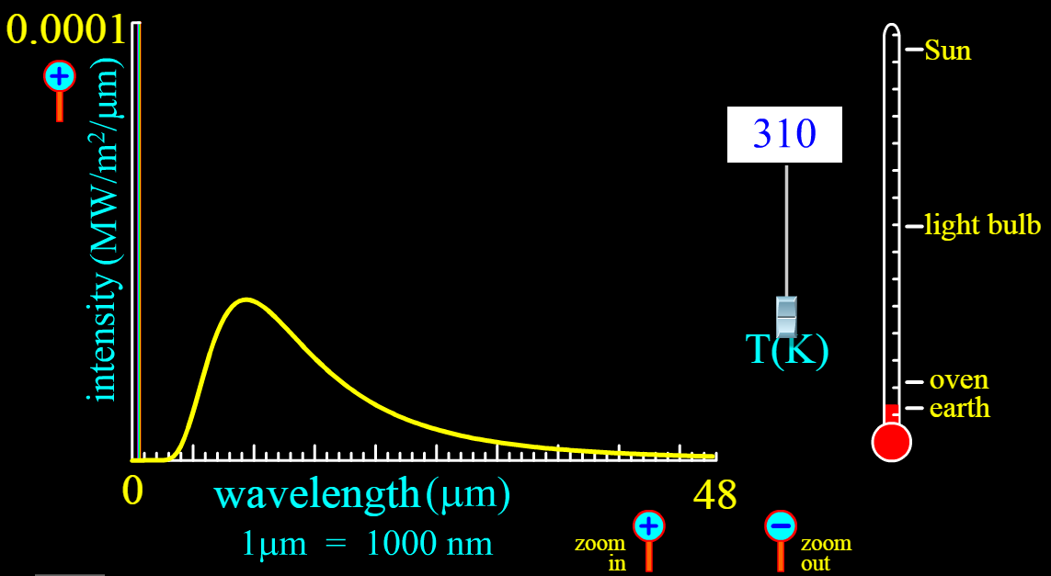

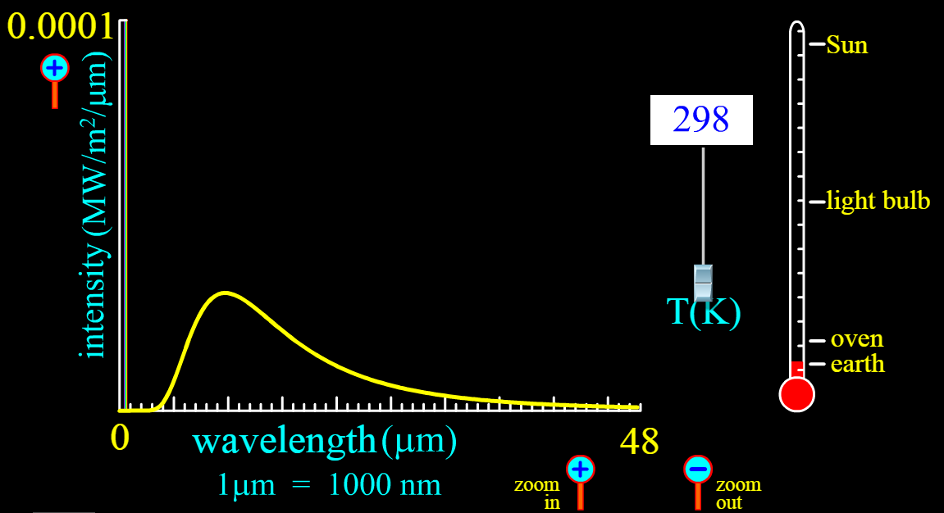

- (a) By considering the units on the axes of the above graph what does the area under the curve (i.e. the size of the space under the yellow curve) represent? [2]

..........................................................................................................................................

..........................................................................................................................................

..........................................................................................................................................

..........................................................................................................................................

- Do incandescent light bulbs radiate more visible light or more heat? Refer to the spectrum of the light bulb in your answer. [2]

..........................................................................................................................................

..........................................................................................................................................

..........................................................................................................................................

In summer people are advised to stay out of the sun with SunSmart Campaigns such as

Slip! Slop! Slap! Throw on a hat!
By referring to the spectrum of the Sun, explain the need for this campaign. [2]

..........................................................................................................................................

..........................................................................................................................................

..........................................................................................................................................

..........................................................................................................................................

- Astronomers regard stars as near-perfect black bodies. A perfect black body will absorb all incoming radiation and emit all outgoing radiation.
(a) Use Wien's displacement law to find the effective surface temperature of the star Rigel if the peak wavelength is 263 nm. [2]

..........................................................................................................................................

..........................................................................................................................................

..........................................................................................................................................

(b) When observing Rigel what colour would one expect to see? Circle your answer.
A a red star B a yellow star C a blue star
Explain briefly. [2]

..........................................................................................................................................

..........................................................................................................................................

..........................................................................................................................................

- Briefly explain the ultraviolet catastrophe originally associated with Blackbody radiation.
[4]
..........................................................................................................................................

..........................................................................................................................................

..........................................................................................................................................

..........................................................................................................................................

..........................................................................................................................................

..........................................................................................................................................

..........................................................................................................................................

..........................................................................................................................................

..........................................................................................................................................

..........................................................................................................................................

..........................................................................................................................................

..........................................................................................................................................

..........................................................................................................................................

..........................................................................................................................................

End of Quiz

